New to radio controlled model flying? The first decision you have to make is what transmitter mode you will use. Our advice is talk to your club and your instructor first, but here are the basics:-
Before you buy radio equipment decide how you will make the aircraft follow your instructions. Which hand will you use to manoeuvre the aircraft. The main directional controls are: up or down elevator to change the pitch attitude of the aircraft, and left or right aileron to induce bank, or rudder to turn the aircraft if there are no ailerons. (if your model has no ailerons the rudder would replace the ailerons and the rudder would be ignored in the diagrams below).
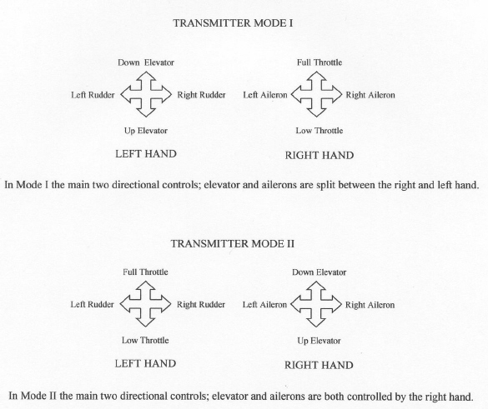

WHICH MODE SHOULD YOU USE?
There is little doubt that what ever transmitter mode is used, familiarity is the key to successful flying. No one can say one way is right or wrong and there should be no criticism of others who are on a different mode to you. The facts are that there are many World and International class competition fliers who use each mode. We generally talk of Mode 1 and Mode 2 but there are Modes 3 and 4 and I have even seen variations on these which maybe called Modes five, six and so on, but any reference to a Mode numbered above 2 is really insignificant and would complicate the issue for anyone new to the hobby, it is sufficient to say that those who fly that way are happy to do so because they have learnt to fly that way, and if you choose an instructor using this mode that will be fine for you too.
For anyone wanting to learn to fly it is most important to liaise with your intended club for advice, and to make sure there is a competent flyer who is happy to teach you on the mode you choose to fly on.
It is also important to choose a mode which will allow you to operate the main control sticks to their full deflection, i.e. to all four corners of the gimbals, and be able to input one or more controls to their full movement without unintentionally moving an adjacent unwanted control. Consideration for which mode to use may be the size of your hands and length of your thumbs, length of the transmitter sticks, which on some transmitters are adjustable, and whether you use a neck strap or a full tray to hold your transmitter. Most members at NASA use Mode I, sometimes with a neck strap, with the pads of our thumbs placed on the top of the transmitter control sticks. If a tray and neck strap are used the control sticks are usually held between the thumb and forefinger. Remember to make sure you can reach all auxiliary switches whilst using the control sticks to remain in full control of your model at all times.

Why so many different modes?: Mode 1 is tradition. In the infancy of radio control there was no other way to fly, manufacturers and technology predicted that this was the only way. The two main control forces, ailerons and elevator were split, elevator on the left hand and ailerons on the right, but more about this later. Mode 2, I think became accepted as a more akin to what happens in the cockpit of a full size aircraft where the main control column operates both ailerons and elevator. Which is the best mode will be argued while ever there is a choice. Remember familiarity is the important factor, choose a method in consultation with your instructor and stick to it.
This paragraph relates to personal experience. Having flown control line stunt in the late 50s and 60s I was the only flier to fly with my 'up line' at the bottom of the control handle, possibly because I am left handed, but mainly because I was self taught, I had no expert guidance when I started and I thought that was the way it was done. This did not detract from my ability to fly accurate manoeuvres. Some time later I did try to change to fly the same way as others do, and it was a disaster. The lesson here is pick a transmitter mode and stick with it, it is practice that improves your flying not the transmitter mode you use. Secondly I have suggested that Mode 2 has grown in popularity because it emulates full size practice, having flown both full size and models, I found no relationship between the two. I flew Cessna's for over twenty years and models on Mode 1 since 1966 (a system called reeds in those days), and it never once crossed my mind whilst I was flying what I would do in the other flying situation. Flying has to be a natural reaction to put the correct control in at the right time, you should not have to think about it, and that comes with practice, practice, practice". However relating aerodynamics to both types of flying can be useful and give an interesting comparison, but that is another story.
Enough of opinion back to facts: Manufacturers now probably produce more Mode 2 transmitters than Mode 1, that was not always the case. Retailers will generally sell to the uninitiated what they have in stock. My advice would be know what you want to buy before you actually open the door of your retailer. Talking to members of your intended model club before you buy anything is essential. You will save yourself aggravation and possibly a lot of money by buying the right equipment the first time.
The mode on some transmitters can be changed at home, others may have to be returned to the service agent, but some cannot be changed and must be purchased in the required configuration.
So how did it all evolve? Originally ground based transmitters, (large metal boxes too heavy to hold, with full wave aerials of some eight feet high) had a remote button on an extension cable which was pressed when you wanted the aircraft to change direction. The first press would turn it one direction the next press would turn it the other, if you were lucky. Valves were used both in the transmitter and receiver and consequently high voltage and heavy batteries were required, typically 90v Ht and 1.5v Lt for the transmitter. Receivers used 67.5v Ht and 1.5v Lt with 4.5v required for the actuator, (the predecessor to the servo). Only one control was possible and that was usually worked by a twisted a rubber band which was wound before each flight. A relay in the receiver made the actuator turn 90 on each push of the transmitter button. Vibration was a huge problem for valves, relays, actuators and receivers. Receivers were suspended in cavernous fuselages on rubber bands. Later actuators allowed the Tx button to be pressed once for left rudder and twice for right rudder, removing the need to remember what the last command was. The 27meg waveband was used but transmitters simply had press button to switch the carrier wave switched on or off so only one model could operate at any one time. You needed a transmitting licence, 7/6p (37½p) for 5 years. Success of controlled flight was limited.
A typical hand held single channel 'carrier wave' valve transmitter and receiver, the elastic band driven actuator is at the front right.
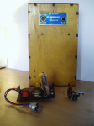
Transmitters (referred to as Tx) and receivers (Rx) were made smaller, operating voltages reduced and Super-hetrodine receivers made it possible to fly up to six aircraft at one time on spot frequencies. Early on crystals on one of the six 'spot' frequencies were soldered into the receiver but later some could be plugged in to change to another spot frequency. Transisterisation made things much easier. Progress meant more controls were possible and state of the art single channel systems had a crude elevator and throttle control, but it was all a bit hit and miss.
During the middle 60s transistorised 10 or 12 channel bi-simultaneous transmitters became available, (that means you could use one control on one side of the Tx and one on the other side at the same time). Feeding in elevator or throttle or elevator trim with your left hand at the same time as operating rudder or aileron with your right hand was now possible. Now if you have followed that you will now be understanding where Mode 1 originated. Top of the range were Tx's with two way leaf spring control switches for each control surface, tuned reed receivers and Bonner servos, really was the gear to fly in those days. This let models develop as reliability and up to six functions on the aircraft could be used, although twelve channels would be necessary to do this. The control movement to the control surfaces was all or nothing. Neutral or full were the only options. However with some mechanical linkages the elevator could be trimmed through a second servo, but in the air you had no way of knowing where the trim had stopped other than watching the aircraft in flight. The same was true of throttle, full and low was set up, but in between the only reference was the noise the engine was making in flight (no silencers were used in those days) and of course the attitude of the model. Receivers with 28 wires wires and Bonner servo with five leads each were supplied without plugs or sockets so each modeller had to provide their own reliable system to make them work. Power was supplied by DACS which were the forerunner of the Nicad, we used 6 volts with a centre tap to allow the servo to work in both directions. Frequency crystals were also soldered in so there was no easy way of changing your frequency.
Below: MinX reed Transmitter and 10 channel receiver (US equipment bought in 1964 through UK agent Pete Waters, Porthcawl, Wales), note the reed bank which provided switching to the servos and the receiver with a 'state of the art' Bonner Servo this was a Duramite with a self assembly amplifier fitted. Servos fitted with Bonner amplifiers were called Transmites. (a pound coin is shown to illustrate size). Price for a full 10 channel system was about 12 times the average weekly wage.
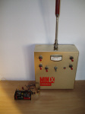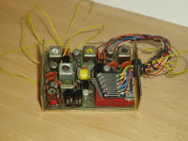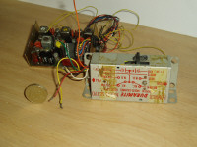
At around the same time, a type of proportional system for rudder and elevator (pictured below) was being developed and as we had one of the most successful developers of this system in our club the interest was very intense. Terry Tippett went on to be the countries biggest supplier and manufacturer of Galloping Ghost, (The trade name for the galloping ghost system was Gallatrol, and later, proportional equipment under the name of Micron Radio Control). The aircraft rudder and elevator were connected with an angled lever which continuously oscillated around a 270° arc. The aircraft tended to wag its tail in the air as the elevator and rudder flapped. The Tx had one control stick very similar to the ones we use today which when operated biased the elevator and rudder in the direction of the stick. The oscillations varied to allow the control surfaces to stay longer in the stick position and therefore a simple form and the first proportional control system was born, and just may have lead some modellers to use transmitter Mode 2. The two buttons seen on the transmitter below are high and low throttle.
Gallatrol Galloping Ghost
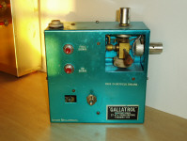
The original proportional systems were very straight forward, four or five functions/servos with adjustable trims and that was it. When a set was purchased with four servos two servos operated in the opposite direction to the others to assist installation. To change the direction of a servo two of the three wires on the feed back potentiometer inside the servo, and the wires connecting the motor had to be crossed over.
Another early variation on the proportional transmitter was that the rudder control was not on a separate gimbal, the transmitter just had one control stick and the rudder control was a twist knob on the top of the main gimbals, three controls on the same stick. Throttle was operated on a separate knob on the side of the Tx. This type of transmitter was referred to as cuddle box. Your left fore arm supported the Tx whilst your left hand operated the throttle on the right hand side of the box. All flying was done with the right hand. Another 'lean' towards Mode 2. Over the years R/C gear has developed at a pace as modern electronics have made our gear lighter, smaller and so much more versatile, and the worlds top fliers will continue to exploit every possibility it brings.
.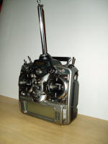
Shown here is the JR PCM10x, circa 2000, 10 proportional channels with touch screen programming for adjustments, trimming
and setting up flight modes. (The aerial is retracted in this view and would extend to around 3 feet whist flying)
From around 2010 model flyers started to convert from 35 MHz to 2,4 GHz so once the receiver is bound to the transmitter which has to be done before the system will work and my have to be repeated, there is no danger of interference from other transmitters and therefore there is no need for frequency control at the flying field. Just make sure you trun your transmitter o first then yur receives and transmitter off first after flying.
The only extra precaution 2.4 GHz brings to operating radio control is that you have to be sure your receiver battery is in good condition and meets the requirements set out in the operating instructions of your equipment.
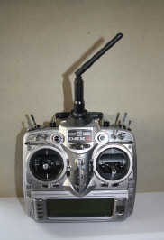
Transmitters for 2.4 GHz look very similar to those on 35MHz except for the aerial which is very much shorter and does not extend.
For hints and tips on preparing a model for the first flight, click here.

